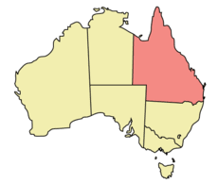
RECENTLY MIGRATED ENGINEERS SUPPORT PROGRAM [RMESP]
APPLICATION FORM
This form is to be used by any of the recently migrated engineers who wish to make use of this new program where they will be assisted to make contact with a suitable mentor in their desired field of work to provide career support. Please read the accompanying information pack for full details of the workings of this program before filling in the information below.
First Name: ………………………………….
Last Name:………………………………..
Contact Phone Number:…………

Email Address: ………………………………

Engineering Discipline:………………..

Years of Experience:………………………..

Visa Category:……………….

Date arrived in Queensland:………………
Nature of assistance currently sought:
……………………………………………………………………..
……………………………..
Signature
Instructions:
- Please download this application/fill up /sign and send to secretary@ieslqld.org
- If you wish to provide further information -please include as annexures

THE INSTITUTION OF ENGINEERS SRI LANKA
QUEENSLAND CHAPTER

